State and Permission Matrix
Two questions on one page: who may do what (role and department), and what may be done in each status (the locks). Both are checked by the backend on every call; the frontend only hides what a user may not use.

1. Roles
Role | Department | Meaning
Admin | any (only a label) | does everything
Worker | Sales | Sale Worker: quotations and production orders before the start
Worker | Factory | Factory Worker: production, stock, purchase

A Worker must have the department Sales or Factory; the department decides the access. The role check comes before the check that the record exists: a user who may not touch a record gets 403, never 404.

2. Who may do what
Area | Action | Admin | Sale Worker | Factory Worker
Dashboard | order tiles | yes | yes | yes
Dashboard | invoice tiles and chart | yes | no | no
QT | see, create, change, print | yes | yes | no
QT | upload customer PO, Confirm, delete a Draft | yes | yes | no
Production order | read | yes | yes | yes
Production order | create or change before the start | yes | yes | no
Production order | Start production (deducts stock) | yes | no | yes
Production order | Record progress | yes | no | yes
Production order | change or reopen a Completed process | yes | no | no
Production order | evidence files: read | yes | yes | yes
Production order | evidence files: upload, delete | yes | no | yes
Stock | read materials, lots, movements | yes | yes | yes
Stock | Add / Deduct / Adjust a lot | yes | no | yes
Materials | create, change, delete | yes | no | no
Purchase | PO: create, change, print, move status, pay, files | yes | no | yes
Suppliers | read | yes | no | yes
Suppliers | create, change, delete | yes | no | no
Customers | read | yes | yes | no
Customers | create, change, delete | yes | no | no
Products | read | yes | yes | yes
Products | create, change, delete | yes | no | no
Accounting | invoices, payments, receipts | yes | no | no
Users | read, create, change, delete | yes | no | no

Menus follow the same table: an entry shows only for the roles and departments that may use it.

3. Statuses and what each allows

QT
Status | Customer and lines | Other fields | Delete | Confirm | Next
Draft | change | change | yes | yes (once) | Confirmed
Confirmed | locked (409 QT_LOCKED) | change | no (409 IN_USE) | already done: shows the existing order | –

Confirm needs a customer and at least one line. A missing customer PO file is only a warning. Confirm makes one Draft production order and copies the PO file to it.

Production order (status is computed from its processes)
Status | Edit lines and processes | Start | Record progress | Next
Draft, not started | yes | needs a line, a process on every line and enough stock (409 ORDER_NOT_READY, 409 STOCK_SHORT) | no (409 ORDER_NOT_STARTED) | In progress
In progress | no (locked by the start) | already started | yes | Completed
Completed | no | – | no, except an Admin reopening a process (note required) | invoiced
Invoiced | no | – | no (409 ORDER_INVOICED) | –

Process
Status | Quantity | Who may change
Not started | 0 | Admin, Factory Worker
In progress | partial | Admin, Factory Worker
Completed | the full quantity | Admin only; reopening needs a note (403 COMPLETED_LOCKED for a Worker)

Purchase order
Status | Change lines | Delete | Files | Payment | Next (by hand, one step only)
Draft | yes | yes | yes | no | Sent
Sent | no (409 PO_LOCKED) | no | yes | no | Received
Received | no | no | yes | once (409 ALREADY_PAID) | –

Received adds the stock once, into the lot typed for each line; a second Received changes nothing (409 INVALID_STATUS_CHANGE). Payment before Received answers 409 PO_NOT_RECEIVED. The amount must equal the total.

Invoice
Status | Payment | Result
Unpaid | one full payment (amount = total) | Paid
Paid | no (409 ALREADY_PAID) | receipt issued, once

An invoice is made only for a Completed order (409 ORDER_NOT_COMPLETED), one per order (409 INVOICE_EXISTS), as a snapshot. It locks the progress of the order.

Supplier (the only record with an Active switch)
Active | New or changed PO | Existing POs
yes | can be chosen | unchanged
no | cannot be chosen | stay as they are

4. One job through the statuses
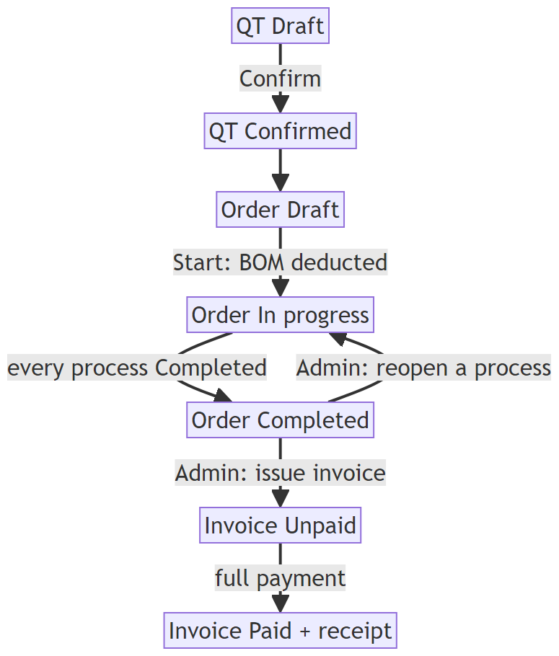

5. Locks at a glance
Lock | Starts when | What it blocks | Error
QT locked | Confirm | change of customer and lines, delete | QT_LOCKED, IN_USE
Order locked | Start production | change of lines and processes | ORDER_LOCKED
Completed process | process Completed | change by a Worker | COMPLETED_LOCKED
Order invoiced | invoice issued | progress updates | ORDER_INVOICED
PO locked | status leaves Draft | change and delete of the PO | PO_LOCKED
PO file copy | Confirm QT | delete of the PO file copy on the order | FILE_LOCKED
In use | another record uses it | delete of customers, products, materials, suppliers | IN_USE

